SAT Math Problems

1.  In a certain city, the average number of jobs available each year has been estimated to decrease by $4\%$ annually since 2019. If the initial number of available jobs in 2019 was 10,000, which of the following expressions best represents the number of available jobs in 2024?

A. $10,000{\left(0.96\right)}^{5}$

B. $10,000{\left(0.96\right)}^{4}$

C. $10,000{\left(0.04\right)}^{5}$

D. $10,000{\left(0.04\right)}^{4}$

2.  What is the solution (x, y) to the given system of equations? $2x+3y=12$, $x=2$

3.  The graph of the following system of equations is shown. Which system of equations is represented by the graph?

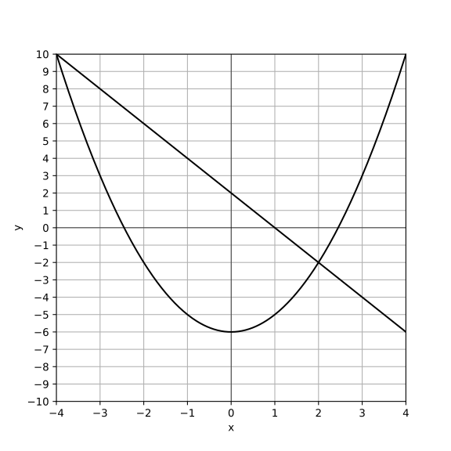

A. $y=x^{2}−6$   &amp; $y=−2x+2$

B. $y=x^{2}−6$   &amp; $y=−2x−2$

C. $y=x^{2}−6$   &amp; $y=2x+2$

D. $y=x^{2}+6$   &amp; $y=−2x+2$

4.  The product of a positive number y and the number that is 16 less than y is equal to 80. What is the value of y?

5.  A research organization receives a grant of $\$12,000$ for an AI project. The first 5 months costs $\$2,000$ per month. After that, the monthly cost decreases to for each of the following months. If the total budget is exhausted after m months, where $m>5$, which equation represents this situation?

A. $2000×5+1500×(m−5)=12000$

B. $2000×5+1500×(m−5)=9000$

C. $2000×m=12000$

D. $1500×m=10000$

6.  A rectangle has a length of 18 meters and a width of 6 meters. If both the length and width are increased by a scale factor of 4 to create a new rectangle, what will be the area of the new rectangle in square meters?

A.    1728

B.    1296

C.    864

D.    324

7.  A factory is considering implementing a robotic system that will automate certain tasks, reducing the labor needed by approximately . Currently, the factory has 250 workers, each responsible for tasks that cost the factory in wages annually. If the company integrates the robotic system, they project that the labor savings will allow them to increase production by while maintaining the same labor costs for the remaining workers. What is the overall annual cost the factory can expect after implementing the robotic system, before accounting for any additional operational costs?

A. $\$3,000,000$

B. $\$2,500,000$

C. $\$2,250,000$

D. $\$1,750,000$

8.  Which equation defines the linear function $f$ that passes through the points (0, 1) and (3, 3)?

A. $f(x)=\frac{2}{3}x−1$

B. $f(x)=\frac{2}{3}x+1$

C. $f(x)=\frac{1}{2}x+1$

D. $f(x)=\frac{1}{3}x+3$

9.  Which equation represents the linear function that passes through the y-intercept at $(0,\frac{1}{2})$ and has a slope of $\frac{2}{3}$?

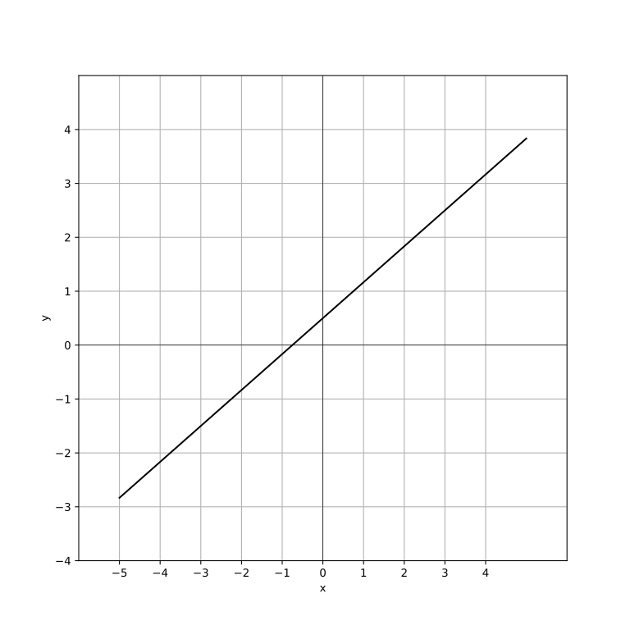

A. $f(x)=\frac{2}{3}x−\frac{1}{2}$

B. $f(x)=\frac{2}{3}x+\frac{1}{2}$

C. $f(x)=−\frac{2}{3}x+\frac{1}{2}$

D. $f(x)=−\frac{2}{3}x−\frac{1}{2}$

10.  In ∆ABC, ∠B is a right angle and the length of BC is 180 millimeters. If $cos(A)=\frac{4}{5}$, what is the length, in millimeters, of AB?

A.   200

B.   220

C.   240

D.    260

SAT Math Solutions

1.  In a certain city, the average number of jobs available each year has been estimated to decrease by $4\%$ annually since 2019. If the initial number of available jobs in 2019 was 10,000, which of the following expressions best represents the number of available jobs in 2024?

A. $10,000{\left(0.96\right)}^{5}$

B. $10,000{\left(0.96\right)}^{4}$

C. $10,000{\left(0.04\right)}^{5}$

D. $10,000{\left(0.04\right)}^{4}$

## Answer

A

## Solution

This problem tests the student’s understanding of exponential decay and their ability to apply the formula to a real-world context. The student needs to know how to use the decay formula and understand the concept of annual percentage decrease.  
To solve this problem, the student should identify the initial value (10,000 jobs) and the decay rate ($4\%$). They should then use the exponential decay formula: $A=P{\left(1−r\right)}^{t}$, where $A$ is the amount after time $t$, $P$ is the initial amount, $r$ is the rate of decay, and $t$ is the time in years. Here, $P=10,000$, $r=0.04$, and $t=2024−2019=5$ years.  
Remember to convert the percentage into a decimal by dividing by 100 ( $4\%$ becomes 0.04). Use a calculator to ensure accuracy when raising numbers to a power and when performing multiplication.  
Be careful with the exponent; make sure to correctly calculate the number of years ($2024−2019=5$). Also, ensure that you subtract the decay rate from 1 to get the correct base for the exponent. This problem is a typical example of exponential decay in a real-world scenario. It assesses the student’s ability to apply mathematical concepts to practical situations, a key skill for the SAT.  
Mastery of exponential functions and decay rates is crucial for tackling advanced math problems effectively.  
  
Since the jobs decrease by $4\%$ each year, the decay factor is $1−0.04=0.96$.  
The formula for the number of jobs after n years with a decrease rate of $r\%$ is $J=J0⋆{\left(1−r\right)}^{n}$.  
Here, $J_{0}=10,000$, $r=0.04$, and $n=5$ (from 2019 to 2024): $J=10,000{\left(0.96\right)}^{5}$

2.  What is the solution (x, y) to the given system of equations? $2x+3y=12$, $x=2$

## Answer

$(2,\frac{8}{3})$

## Solution

This problem is designed to test the student’s ability to solve systems of linear equations, specifically when one equation is already solved for one variable. It assesses understanding of substitution and basic algebraic manipulation.  
To solve this system of equations, substitute the value of x from the second equation into the first equation. Then solve for y. Once y is found, combine it with the given x to form the solution as an ordered pair (x, y).  
Since one of the equations is already solved for x, substitution is straightforward. Remember to keep your work organized and substitute carefully to avoid mistakes.  
Be careful with arithmetic operations when substituting and solving for y. Also, ensure that you correctly substitute the entire value of x into the first equation to avoid any errors.  
This type of problem is a straightforward test of your ability to handle systems of linear equations where one variable is already isolated. It’s essential to understand substitution and ensure each step is meticulously followed to avoid simple arithmetic errors. Mastery of this concept is crucial as it forms the foundation for more complex algebraic problem-solving on the SAT.  
  
Substitute $x=2$ into the first equation: $2(2)+3y=12$ $4+3y=12$
  
  
Subtract 4 from both sides to isolate the term with y: $3y=12−4$ $3y=8$
  
  
Divide both sides by 3 to solve for y: $y=\frac{8}{3}$

3.  The graph of the following system of equations is shown. Which system of equations is represented by the graph? 

A. $y=x^{2}−6$   ; $y=−2x+2$

B. $y=x^{2}−6$   ; $y=−2x−2$

C. $y=x^{2}−6$   ; $y=2x+2$

D. $y=x^{2}+6$   ; $y=−2x+2$

## Answer

A

## Solution

This problem is designed to test students’ understanding of graphing quadratic and linear equations and their ability to identify these equations from a given graph. It evaluates whether students can recognize the visual representation of different types of functions and systems of equations.  
To approach this problem, students should first understand that the graph includes a quadratic equation and a linear equation. They need to identify these from the given options. First, find the vertex and the direction of the parabola described by the quadratic function, then confirm the slope and y-intercept of the linear equation. The intersection points, if any, should be consistent with the graph of the system.  
Review the shapes and properties of graphs of quadratic and linear equations. Quadratics form parabolas, typically opening upwards or downwards. Linear functions form straight lines with a constant slope. Visualizing or sketching the graph can help confirm the correct equations.  
Be careful with the signs and coefficients in the functions. It is easy to misinterpret the slope or y-intercept of the linear equation or the a, b, and c coefficients in the quadratic equation. Ensure that your identified equations match the graph precisely.  
This type of SAT question assesses the ability to connect algebraic equations to their graphical representations. Mastery of this skill is crucial for solving a wide range of math problems, both in SAT and real-world applications. Recognizing the characteristics of different types of equations on a graph is key to efficiently solving these types of problems.  
  
To solve, we need to plot the functions and observe the graph.  
The intersections of the quadratic and linear functions occur where their values are equal.  
By setting $y=x^{2}−6$ equal to $y=−2x+2$, we find the points of intersection.

4.  The product of a positive number y and the number that is 16 less than y is equal to 80. What is the value of y?

## Answer

20

## Solution

This problem tests the student’s ability to set up and solve a quadratic equation derived from a word problem. The student must understand how to translate a verbal description into a mathematical expression and solve for the unknown variable.  
To solve the problem, start by defining the variable: let y be the positive number. According to the problem, the product of y and (y - 16) is 80. Set up the equation $y(y−16)=80$. Expand this to get $y^{2}−16y=80$, then rearrange it to form a standard quadratic equation: $y^{2}−16y−80=0$. Solve this equation using the quadratic formula, factoring, or completing the square.  
Try factoring first, as it’s often quicker if the equation is factorable. Look for two numbers that multiply to -80 and add up to -16. If factoring is cumbersome, use the quadratic formula: $y=\frac{−b±\sqrt{b^{2}−4ac}}{2a}$.  
Be sure to check both solutions of the quadratic equation, but remember that only the positive solution is valid since y is a positive number. Also, double-check your arithmetic when expanding and rearranging the equation.  
This problem is a typical example of how SAT tests a student’s ability to handle quadratic equations, especially those derived from word problems. Understanding how to translate a problem statement into a mathematical expression and correctly solving quadratic equations are key skills. Practicing these will help you solve such problems more efficiently and accurately, which is crucial under the time constraints of the SAT.  
  
1. Set up the equation: .  
2. Expand the equation: .  
3. Rearrange the equation to standard quadratic form: .  
4. Use the factorization:   
5. Find the roots: .  
6. Since y must be positive, the value of y is 20.

5.  A research organization receives a grant of $\$12,000$ for an AI project. The first 5 months costs $\$2,000$ per month. After that, the monthly cost decreases to for each of the following months. If the total budget is exhausted after m months, where $m>5$, which equation represents this situation?

A. $2000×5+1500×(m−5)=12000$

B. $2000×5+1500×(m−5)=9000$

C. $2000×m=12000$

D. $1500×m=10000$

## Answer

A

## Solution

This problem aims to test the student’s ability to translate a real-world scenario into a linear equation. It evaluates the understanding of piecewise functions and how to represent changing rates within a single equation.  
First, identify the cost for the first 5 months and then for the remaining months. Use this information to formulate a piecewise linear equation that describes the total cost as a function of the number of months, m.  
Break down the problem into two parts: the first 5 months and the months after that. Calculate the total cost for the first 5 months and then add the cost for the remaining months.  
Ensure you correctly apply the conditions: $m>5$. Also, be cautious about correctly calculating the transition point at 5 months and applying the correct rate for the subsequent months.  
This type of problem is common on the SAT to test algebraic reasoning and the ability to model real-world situations. Mastering this will help you handle similar problems efficiently. Always break down the problem into manageable parts and carefully apply the given conditions to avoid errors.  
  
For the first 5 months, the cost is $\$2,000×5=\$10,000.$  
The total budget is $\$12,000$, so the remaining months should not exceed the given budget.  
The equation representing the total cost after m months is: $2000×5+1500×(m−5)=12000$.

6.  A rectangle has a length of 18 meters and a width of 6 meters. If both the length and width are increased by a scale factor of 4 to create a new rectangle, what will be the area of the new rectangle in square meters?

A.    1728

B.    1296

C.    864

D.    324

## Answer

A

## Solution

This question aims to test the student’s understanding of scale factors and how they affect the dimensions and area of geometric shapes. The student needs to apply the concept of ratios and proportional relationships to solve the problem.  
To solve this problem, the student should first recognize that increasing both the length and width of the rectangle by a scale factor of 4 means multiplying each dimension by 4. Then, the student should calculate the new dimensions and use the formula for the area of a rectangle (length $×$ width) to find the area of the new rectangle.  
Remember that when scaling dimensions of a shape, all linear dimensions are multiplied by the scale factor. For areas, the scale factor is squared. Also, double-check your calculations to ensure accuracy.  
A common mistake is to confuse the scaling of dimensions with the scaling of area. Ensure you apply the scale factor correctly to each dimension first before calculating the area. Avoid directly multiplying the original area by the scale factor, as this will give an incorrect result.  
This type of problem is typical of SAT questions focused on ratios, rates, and proportions. It assesses your ability to apply geometric scaling principles accurately. Mastery of these concepts is crucial for performing well in the Problem Solving and Data Analysis category. Practice similar problems to become familiar with the steps and to minimize errors during the actual test.  
  
1. Calculate the new length using the scale factor: New length = Original length $×$ Scale factor = $18×4=72$ meters.  
2. Calculate the new width using the scale factor: New width = Original width $×$ Scale factor = $6×4=24$ meters.  
3. Calculate the area of the new rectangle: Area = New length $×$ New width = $72×24=1728$ square meters.

7.  A factory is considering implementing a robotic system that will automate certain tasks, reducing the labor needed by approximately . Currently, the factory has 250 workers, each responsible for tasks that cost the factory in wages annually. If the company integrates the robotic system, they project that the labor savings will allow them to increase production by while maintaining the same labor costs for the remaining workers. What is the overall annual cost the factory can expect after implementing the robotic system, before accounting for any additional operational costs?

A. $\$3,000,000$

B. $\$2,500,000$

C. $\$2,250,000$

D. $\$1,750,000$

## Answer

C

## Solution

The problem is designed to test the student’s ability to understand and manipulate exponential functions and percentage changes in a real-world context. It requires understanding of percentage reduction and increase, and how they affect cost calculations in a factory setting.  
First, calculate the number of workers reduced by the robotic system ( $40\%$ of 250). Subtract this number from the current workforce to find the remaining number of workers. Calculate the total labor cost for these remaining workers. Since production increases by $30\%$ with the same labor cost, the overall annual cost will simply be the cost of the remaining workers’ wages, which remains unchanged.  
Break down the problem into smaller parts: calculate the number of workers reduced, then calculate the labor cost of remaining workers. Remember that the production increase doesn’t affect labor cost directly in the given scenario.  
Be careful not to confuse the percentage reduction in workers with the percentage increase in production. Also, ensure that calculations for percentage changes are accurate and do not mix up percentage with decimal form.  
This problem type is common in SAT exams as it assesses critical thinking and the application of mathematical concepts to realistic scenarios. It evaluates the student’s ability to manage percentage changes and their impacts on costs, which is an essential skill in both academic and real-world settings. Mastery of these concepts can significantly aid in solving similar word problems efficiently.  
  
Calculate the number of workers after implementing the robotic system: $250−(250×0.40)=250−100=150$ workers.  
Calculate the total labor cost for the remaining workers: 150 workers $×$ $\$15,000$ per worker = $\$2,250,000$.  
The overall annual cost the factory can expect after implementing the robotic system, before accounting for any additional operational costs, is $\$2,250,000$.

8.  Which equation defines the linear function $f$ that passes through the points (0, 1) and (3, 3)?

A. $f(x)=\frac{2}{3}x−1$

B. $f(x)=\frac{2}{3}x+1$

C. $f(x)=\frac{1}{2}x+1$

D. $f(x)=\frac{1}{3}x+3$

## Answer

B

## Solution

The problem is designed to test the student’s ability to determine the equation of a linear function from given points on a graph. It assesses understanding of the slope-intercept form and the ability to calculate slope and y-intercept.  
To solve this problem, first find the slope (m) of the line using the formula $\frac{(y2−y1)}{(x2−x1)}$.  
Next, use the slope-intercept form of a linear equation ($y=mx+b$) and substitute one of the given points to solve for the y-intercept (b). Finally, write the equation of the line using the calculated slope and y-intercept.  
Remember to always check your points and slope calculations carefully. Use the formula for the slope and plug in the points accurately. Double-check your work by substituting both points into the final equation to ensure they satisfy the equation.  
Be careful with arithmetic errors when calculating the slope and y-intercept. Ensure that you correctly identify the coordinates of the points and plug them into the formula correctly. Also, remember that the slope-intercept form is $y=mx+b$, not $y=mx−b$ or any other variation.  
This type of problem is common in SAT algebra sections and effectively tests your understanding of linear equations and their graphs. The ability to determine the equation of a line from points is a fundamental skill in algebra. Mastery of this concept will aid in solving a variety of problems involving linear functions and graph interpretations on the SAT.  
  
Step 1: Calculate the slope (m) using the two points (0, 1) and (3, 3):, $m=\frac{3−1}{3−0}=\frac{2}{3}$  
Step 2: Use the point-slope form to find the equation of the line.  
We can use the point (0, 1) because it is the y-intercept.  
The equation becomes: $f(x)=\frac{2}{3}x+1$  
Thus, the correct equation is Option 2: $f(x)=\frac{2}{3}x+1$.

9.  Which equation represents the linear function that passes through the y-intercept at $(0,\frac{1}{2})$ and has a slope of $\frac{2}{3}$? 

A. $f(x)=\frac{2}{3}x−\frac{1}{2}$

B. $f(x)=\frac{2}{3}x+\frac{1}{2}$

C. $f(x)=−\frac{2}{3}x+\frac{1}{2}$

D. $f(x)=−\frac{2}{3}x−\frac{1}{2}$

## Answer

B

## Solution

The problem tests the student’s ability to understand and apply the concept of linear equations, particularly focusing on identifying the slope-intercept form of a line from given parameters.  
Students should recognize that the equation of a line in slope-intercept form is given by $y=mx+b$, where m is the slope and b is the y-intercept. They should substitute the given slope and y-intercept into this formula to find the correct equation.  
Remember the slope-intercept form $y=mx+b$. Directly substitute the given slope ($\frac{2}{3}$) and y-intercept ($\frac{1}{2}$) into the equation to quickly find the answer.  
Be careful not to confuse the slope with the y-intercept. Ensure you place the correct values into the form $y=mx+b$. Also, make sure to correctly simplify fractions if needed.  
This problem assesses a fundamental understanding of linear equations, a critical skill in algebra. Mastery of identifying and manipulating the slope-intercept form is essential for success in more complex algebraic problems. Practicing these types of questions will enhance your ability to quickly and accurately translate between graphical and algebraic representations of lines.  
  
Substitute the slope (m) and y-intercept (b) into the equation of a line: $f(x)=\frac{2}{3}x+\frac{1}{2}$, This equation matches the format of option B.  
Therefore, the correct equation representing the linear function is $f(x)=\frac{2}{3}x+\frac{1}{2}$.

10.  In ∆ABC, ∠B is a right angle and the length of BC is 180 millimeters. If $cos(A)=\frac{4}{5}$, what is the length, in millimeters, of AB?

A.   200

B.   220

C.   240

D.    260

## Answer

C

## Solution

This problem is designed to test the student’s understanding of right-angle trigonometry, specifically the ability to use the cosine function to find the length of a side in a right triangle.  
The student should recognize that in right triangle ∆ABC, with ∠B as the right angle, the cosine of angle A is defined as the ratio of the adjacent side (AB) to the hypotenuse (AC). Given that $cos(A)=\frac{4}{5}$, the student needs to set up the equation $\frac{AB}{AC}=\frac{4}{5}$. Since BC is given as 180 millimeters, and BC is the side opposite angle A, the student can use the Pythagorean theorem to find AC first before finding AB.  
Remember that the Pythagorean theorem can be used to find the hypotenuse when you have one side and the cosine ratio. Set up a ratio equation using $cos(A)=\frac{adjacent}{hypotenuse}$, and solve for the unknown side. Double-check your calculations by ensuring the triangle’s side lengths satisfy the Pythagorean theorem.  
Be careful not to confuse the sides of the triangle. Ensure you correctly identify which side is opposite and which is adjacent to angle A. Also, ensure that your calculations are exact, and consider simplifying fractions or square roots accurately.  
This problem assesses the student’s proficiency in applying trigonometric ratios to solve for missing side lengths in right triangles. Mastery of this concept is essential for solving more complex trigonometry problems in the SAT. The ability to correctly interpret and apply the cosine function is a crucial skill in the geometry section of the test.  
  
Since $cos(A)=\frac{4}{5}$, we have $\frac{AB}{AC}=\frac{4}{5}$., We need to find the length of AB., Since BC is 180 millimeters, BC is opposite to angle A., In a right triangle, we use the Pythagorean identity: ${\left(sin\right)}^{2}(A)+{\left(cos\right)}^{2}(A)=1$., Given $cos(A)=\frac{4}{5}$, find ${\left(sin\right)}^{2}(A)$: ${\left(\frac{4}{5}\right)}^{2}+{\left(sin\right)}^{2}(A)=1$., $\frac{16}{25}+{\left(sin\right)}^{2}(A)=1$., ${\left(sin\right)}^{2}(A)=\frac{9}{25}$, therefore $sin(A)=\frac{3}{5}$., Using $sin(A)$, we have $sin(A)=\frac{BC}{AC}=\frac{3}{5}$., $AC=\frac{BC}{sin(A)}=\frac{180}{\frac{3}{5}}=180×\frac{5}{3}=300 millimeters$., Now, using $cos(A)=\frac{4}{5}$, solve for AB: $AB=cos(A)×AC=\frac{4}{5}×300=240 millimeters$.